SMART WATER SYSTEM

SUBMITTED BY :

Nikhil Gattamaneni

au723921243021

**nikhilgattamaneni25@gmail.com**

INNOVATION

A smart water system innovation project focuses on leveraging advanced technologies and data-driven approaches to improve the management, conservation, and distribution of water resources. Such projects are crucial for addressing the growing challenges related to water scarcity, quality, and sustainable management. Here are some key components and innovations commonly found in smart water system innovation projects:

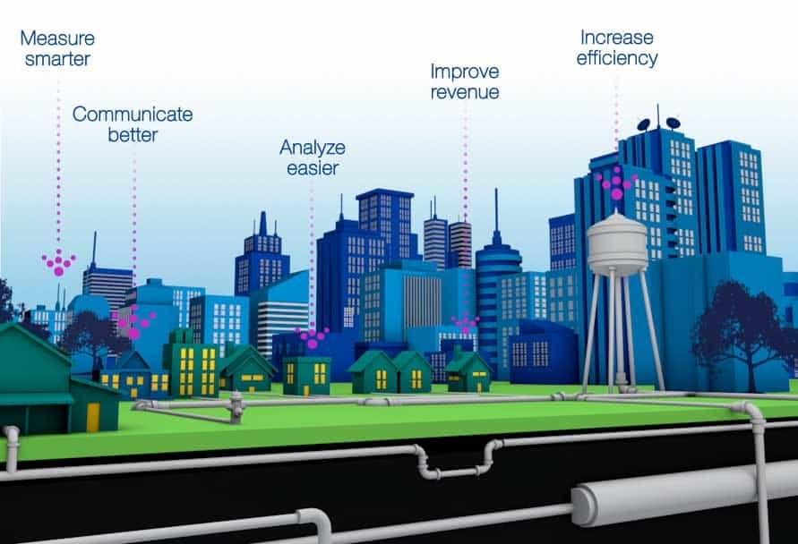

1. **Smart Metering**: Implementing advanced metering infrastructure (AMI) to collect real-time data on water consumption. Smart meters enable both consumers and utilities to monitor usage, detect leaks, and optimize water consumption.
2. **Data Analytics and AI**: Utilizing data analytics and artificial intelligence to process large volumes of water-related data, such as consumption patterns, leakage detection, and quality monitoring, for better decision-making and prediction.
3. **Leak Detection and Management**: Deploying sensors and IoT (Internet of Things) devices to identify and locate leaks in the water distribution network. This helps reduce water loss and infrastructure damage.
4. **Demand Response Programs**: Implementing demand response strategies that encourage consumers to reduce water usage during peak periods, lowering stress on the system and conserving resources.
5. **Water Quality Monitoring**: Integrating sensors to continuously monitor water quality, detecting contaminants, pathogens, or chemical changes in real time. This enhances the ability to respond quickly to potential threats to public health.
6. **Remote Sensing and GIS**: Using satellite imagery and geographic information systems (GIS) to monitor and analyze water resources, track changes in water levels, and plan for resource management.
7. **Integrated Water Management**: Developing holistic systems that connect drinking water, wastewater, and stormwater management, allowing for efficient resource utilization and reducing environmental impacts.
8. **Water Recycling and Reuse**: Implementing advanced technologies to treat and purify wastewater for reuse in non-potable applications, such as irrigation, cooling, and industrial processes.
9. **Smart Irrigation**: Promoting water-efficient irrigation systems, often controlled by IoT devices, to optimize water usage in agriculture and landscaping.
10. **Real-time Monitoring and Control**: Creating a central control system that allows operators to remotely monitor and adjust water distribution, pressure, and quality in real time.
11. **Consumer Engagement**: Developing mobile apps and web platforms to educate and engage consumers in water conservation efforts, offering tips, usage insights, and incentives for reducing consumption.
12. **Infrastructure Resilience**: Upgrading and maintaining water infrastructure to withstand extreme weather events and other potential disruptions.

